SMALL PUMP SOUND INSULATION KIT

The Kit contains:

1 x Sound Absorbing Mat (32mm thick with a black film face on one side 1200 x 900mm)
1 x Anti-Vibration Pad (20mm thick high density rubber panel 1m x 1m)
1 x Can Sta-Put aerosol adhesive
1 x 380ml Acoustic Sealant cartridge
1 x Set Installation Instructions

Please read through these instructions before commencing work to familiarise yourself with the products and how they are to be used.

Stage 1

Materials required

Sharp Stanley type craft knife, Tape measure, Jig Saw (optional), Sealant Gun and Woodworking tools

The pump must first be isolated from the structure where it is sited. The best way to do this is to cut the Anti-Vibration pad to a suitable size to support a small patio type slab then glue it to the substrate where the pump is to be sited. If this is on top of joists then a suitable board will have to be screwed on top of the joists to support it before proceeding. Glue the patio type slab onto the pad then glue another section of pad cut to the same size to the top of the slab. Finally, glue a minimum 18mm MDF panel of the same size onto the top section of pad. Your pump can now be secured to the MDF panel using suitable fixings but take care not penetrate the anti-vibration pad!

Stage 2
Construct an enclosure (if applicable) as large as possible to house the pump using minimum 18mm MDF or use existing enclosure. If ventilation is required, construct a simple baffle as shown on the side view of the illustration below.

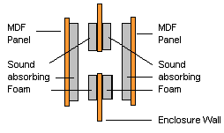

or alternatively, a simple ‘box’ type baffle that very simply, resembles a box with an open end and open side. This can be created from MDF and fixed over a ventilation hole previously cut in the side of the enclosure. The open side of the box should be fixed over the hole so that the open end only is visible from the outside. Air can then freely go through this and in and out of the enclosure which will reduce build up of too much heat if the equipment is run for long periods of time. Whichever type of baffle is constructed it is important that it is lined with the insulation supplied as shown on the diagram. Ventilation may not be required for shower pumps and other equipment that may only be run for short periods. In these cases, construct the enclosure as large as possible to reduce any heat build up that may still occur.

Step 3

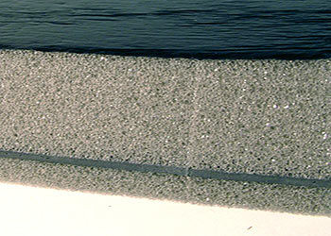 | Sound absorbing Mat is used to line the inside of the enclosure. It should be applied with the black film face visible so the adhesive is applied to the grey foam side only.  Carefully measure and make a note of the dimensions that form the four sides and the top of the enclosure. Be careful to allow for the thickness of the insulation where it meets in the corners.

Using the craft knife, cut the insulation to the required sizes and ensure they fit the relevant section before applying the adhesive.
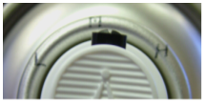
The adhesive is a contact adhesive in an aerosol can
with an adjustable nozzle. You may prefer to adjust
the nozzle to the widest spray pattern by pointing it to
the last clockwise marking in the row of three. Then
apply the adhesive to both the enclosure and the foam by holding the can about 8 inches (20cm) away and spray coat the products.

The spray pattern should ‘web’ onto the surface as shown in the illustration.

Do not apply too much and do not wet the surface. After applying the adhesive you should be able to stick the insulation by careful positioning and applying a firm pressure all over. An instant bond should then be achieved. Continue applying all of the insulation in this manner until the entire inside of the enclosure has been covered.  Finally, fix the insulated enclosure over the pump ensuring it is secure. | 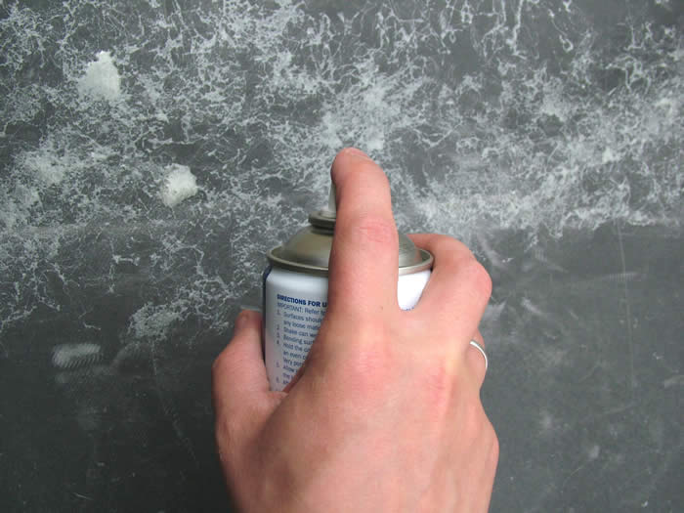

If it is necessary to fit pipes through the enclosure, these should be flexible pipes to reduce noise transmitted along them and the holes in the enclosure cut so they are slightly larger than the pipes. But the holes in the insulation can be an exact fit. Ensure the pipes sit in the middle of the holes then seal them with our Acoustic Sealant supplied in the kit.

The above instructions can be used for isolating and enclosing any noisy machinery or equipment and the larger the enclosure can be built, the more efficient it will be.

Job done

